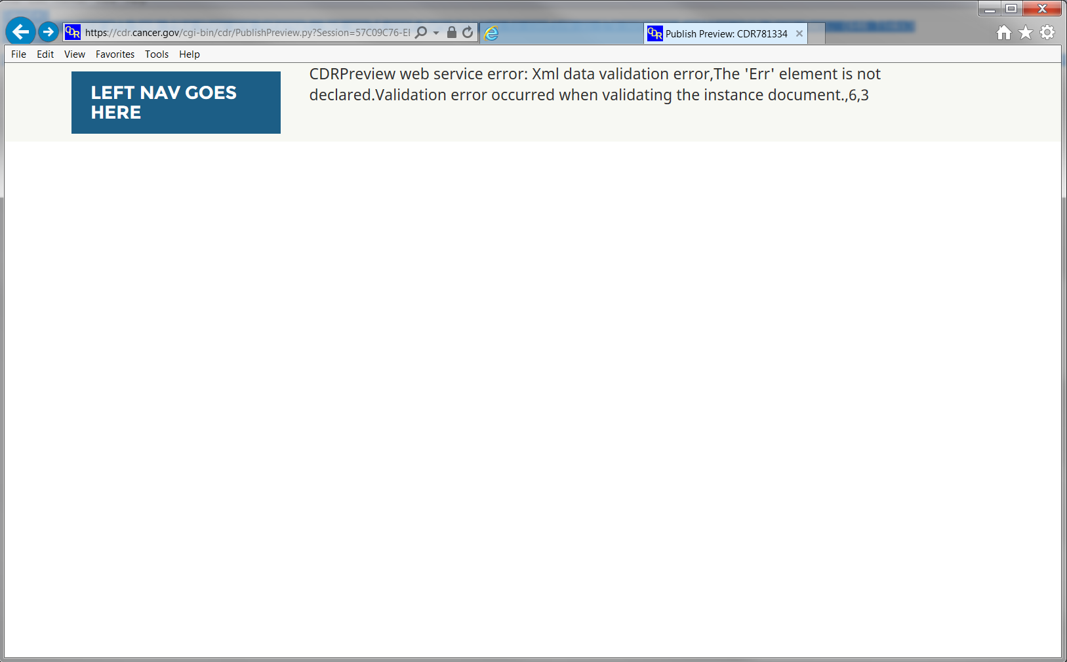

When “http://” is left out of summary URL, you get the following error message:

CDRPreview web service error: Xml data validation error,The 'Err' element is not declared.Validation error occurred when validating the instance document.,6,3